TEJAS P

20231ECE0218

FOOD WASTE MANAGEMENT SYSTEM

**Project Title**: Food Wastage Management System in College Hostels

**Objective:**

The main goal of this project is to analyze and visualize the amount of food prepared, consumed, and wasted in a college hostel using real-world data. It also provides suggestions on how to minimize food wastage and redirect excess food effectively.

**Project Description:**

This project focuses on managing and understanding food wastage in college hostels using Python libraries like **Pandas**, **NumPy**, and **Matplotlib**. It uses a dataset (hostel_food_wastage_large.csv) containing daily records of food prepared, consumed, and wasted. The application allows users to visualize trends, understand waste patterns, and consider practical solutions.

The system is organized into **multiple files**:

* main.py – Runs the application and presents a menu interface.
* data_loader.py – Loads and preprocesses the dataset.
* visualizer.py – Generates plots to show daily trends of food usage.
* menu.py – (Optional) Handles the user interface logic.

**Key Functionalities:**

* Visualize the amount of food prepared, consumed, and wasted daily.
* Display the percentage of food wasted.
* Suggest methods to reduce wastage, such as:
  + Taking only needed portions.
  + Displaying real-time wastage stats in the dining area.
* Recommend options to redirect excess food:
  + Donate to NGOs or food banks.
  + Use for composting or animal feed.

**Technologies Used:**

* **Python 3**
* **Pandas** – For data loading and processing.
* **NumPy** – For numerical calculations.
* **Matplotlib** – For generating line graphs.

**Benefits:**

* Helps the hostel administration monitor food usage.
* Encourages students to be mindful of wastage.
* Promotes sustainable practices by redirecting excess food.

**Problem Statement:**

Amount of Food being wasted in College Hostels

(Food wastage management system)

The amount of food prepared

Amount of food consumed

Help how the food wastage can be brought down

How data can help Students who take food on plates but waste them

How the food being thrown can be redirected to other places

**Data & Relevant Information:**

The system is powered by a CSV dataset (hostel_food_wastage_large.csv) which contains real-world data fields like:

* Date – The specific day the data was recorded
* Food_Prepared – Quantity of food cooked (kg)
* Food_Consumed – Quantity actually consumed (kg)
* Food_Wasted – Quantity thrown away (kg)

From this data, the program can calculate:

* Total food waste
* Percentage waste
* Trends over time
* Days with high/low consumption

**Objective:**

To build a tool that helps analyze food wastage trends, raise awareness among hostel residents, and support smarter food distribution decisions.

**Purpose:**

* To **minimize food wastage** through data-driven decisions.
* To **educate students** on how their individual actions impact food waste.
* To **recommend solutions** for redirecting extra food instead of discarding it.
* To promote **sustainable practices** in hostel food management.

**Operations :**

The program offers the following features:

1. **Summary Chart** – Shows food prepared, consumed, and wasted over time.
2. **Wastage Percentage Display** – Calculates and shows how much food is wasted as a percentage.
3. **Reduction Tips** – Offers practical tips to reduce wastage (like portion control, awareness boards).
4. **Redirection Suggestions** – Gives ideas on where unused food can be sent:
   * Local NGOs
   * Animal shelters
   * Compost facilities
5. **Exit Option** – Gracefully closes the program.

**Expected Outcomes with visual outputs :**

* Hostel authorities and students can **clearly visualize food trends**.
* Identify **days with excess waste** and adjust portions accordingly.
* Use the insights to **inform kitchen planning** (reduce over-preparation).
* **Redirect leftover food** to meaningful causes rather than discarding it.
* Promote a culture of **responsibility and sustainability** within the host

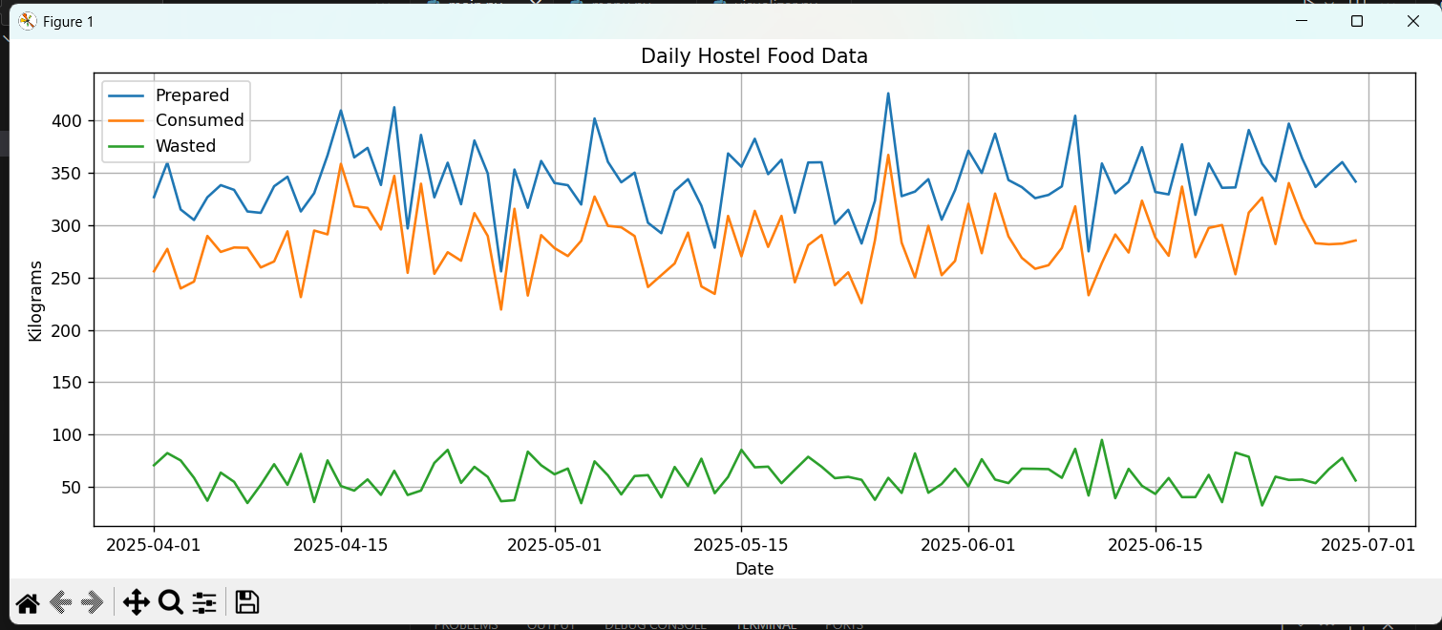

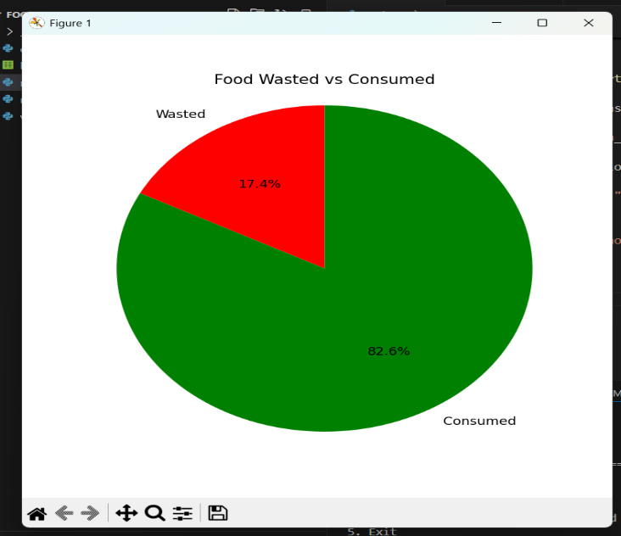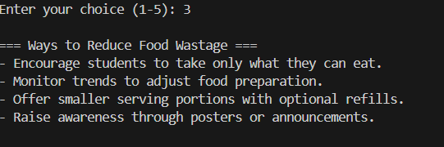

### ****Plan****

This project was approached with a step-by-step plan to ensure smooth progress and effective completion. The planning involved the following key phases:

### 1. ****Problem Understanding****

* Understood the issue of food wastage in college hostels.
* Identified key aspects to study: food prepared, food consumed, and food wasted.

### 2. ****Data Collection****

* Used the dataset hostel_food_wastage_large.csv, which contains daily records of food preparation, consumption, and wastage.

### 3. ****Tool Selection****

* Chose **Python** as the programming language.
* Used libraries: pandas for data handling, matplotlib for visualizations, and numpy for numerical analysis.
* Developed the project using **VS Code**.

### **4**. **Modular Design**

* Broke the program into multiple Python files:
  + data_loader.py – for loading and preprocessing data.
  + visualizer.py – for charts and graphs.
  + menu.py – for user interaction.
  + main.py – the entry point and controller.

### ****DESIGN OF THE PROGRAM:****

### 

### ****Implementation:****

The project was developed using Python, with the help of libraries like Pandas, NumPy, and Matplotlib. The goal was to analyze food wastage in college hostels and suggest practical solutions.

The program is divided into multiple files for better structure. One file loads and processes the dataset, another creates visual charts, and a main file presents a simple menu for users to interact with.

The dataset includes values such as the amount of food prepared and the amount consumed. These were used to calculate how much food was wasted daily.

A command-line menu was added to make the tool easy to navigate. Users can choose options like viewing summary charts, waste percentages, or suggestions to reduce waste.

Basic error handling was included to manage missing files or incorrect inputs. The code was tested to ensure smooth performance with the given dataset.

Overall, the system provides a clear overview of food wastage trends and ideas on how to reduce it or redirect unused food to better use.

### Code and Explanations

This section showcases the key components of the project through code snippets organized by file. Each file plays a specific role in the functioning of the food wastage management system.

### main.py:

**Purpose**: Acts as the entry point of the program. It displays a menu and calls the appropriate function based on user input.

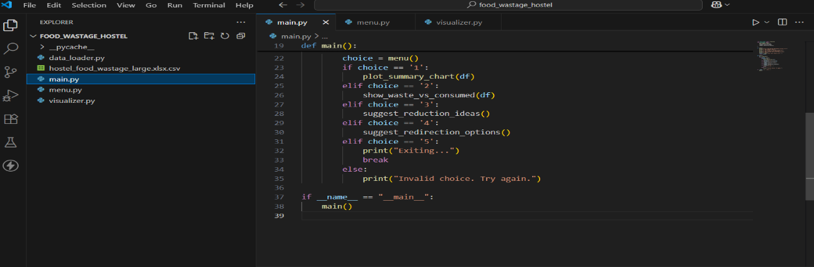

### data_loader.py:

**Purpose**: Handles loading and cleaning of the food wastage dataset.

### 

### visualizer.py:

**Purpose**: Contains functions to visualize key insights using matplotlib.

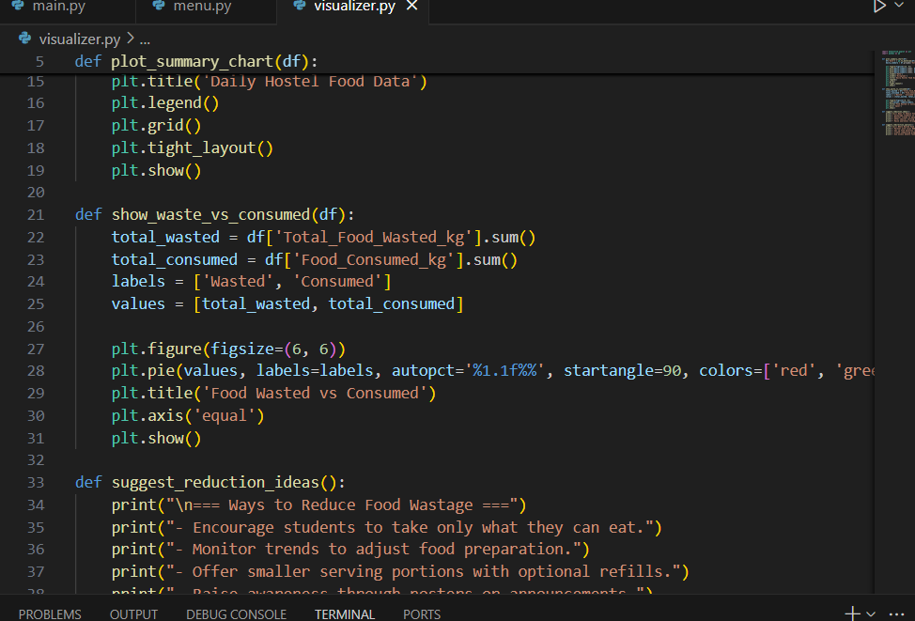

### menu.py :

**Purpose**: Defines the structure of the user interface menu.

### 

### Conclusion

The **Food Wastage Management System** successfully demonstrates how data analysis can be used to understand and reduce food wastage in hostel environments. By collecting real data on food prepared and consumed, this system highlights the amount of food being wasted and provides visual insights that are easy to interpret.

Through features like summary charts and comparison graphs, the system helps in identifying key problem areas and encourages mindful consumption among students. Additionally, it raises awareness on how excess food can be redirected to serve a better purpose rather than being discarded.

This project serves as a foundational step toward building more efficient and sustainable food management practices using simple data science tools like **Pandas**, **Matplotlib**, and **NumPy**.